To get here I basically followed these steps

**Navigate to Responsibility:**

* Order Management Super User or Order Management Setup.
* **Open System Parameters:**
* Navigate to **Setup > System Parameters > Values**.
* This opens the **System Parameters** screen.

**Define Parameters:**

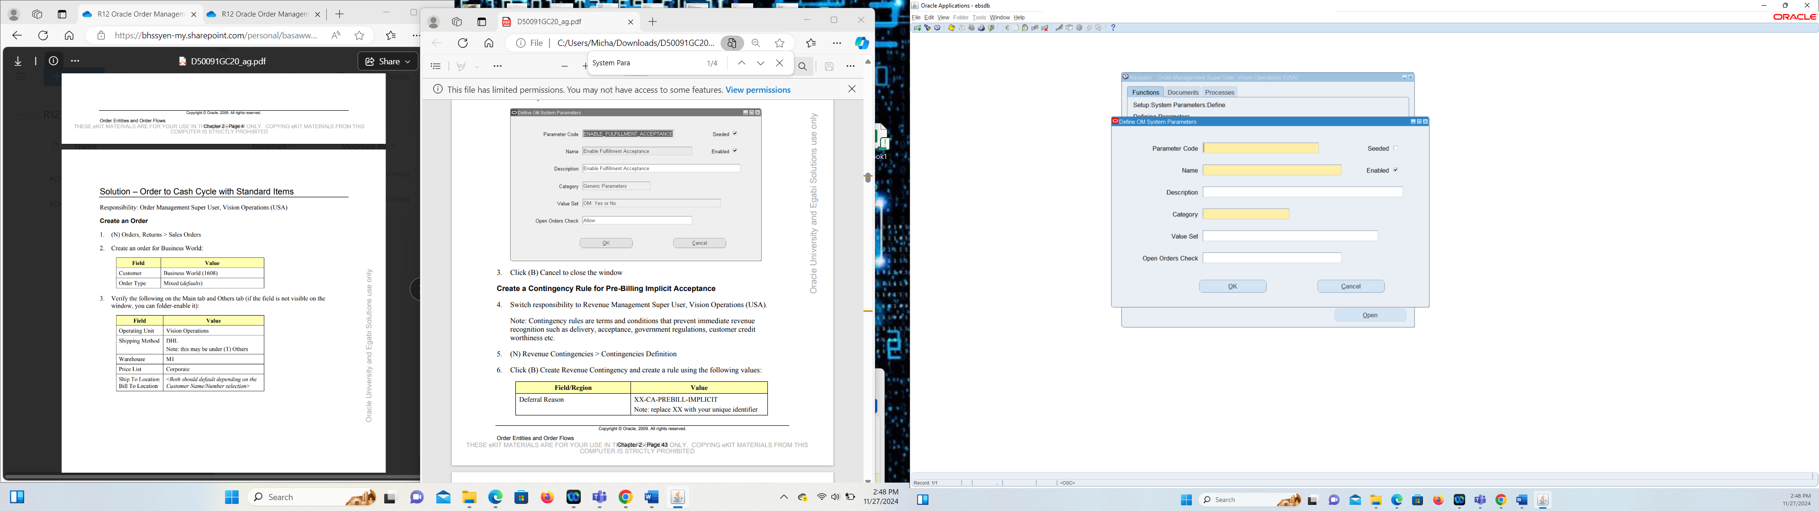

I then filled in the blanks according to the activity guide

I put ENABLE_FULFILLMENT_ACCEPTANCE in Parameter Code

I Put the same for Name and description but lowercase without underscores

Category Generic Parameters

Value Set I put OM: Yes or No

I put allow for Open Orders CHeck

* Select the responsibility for **Order Management** (e.g., Order Management Super User).

**2. Navigate to Customers Screen:**

* Go to **Customers > Standard**

Once you make it to the standard page in order Management in the simple search page for the name field you put Ame% and that essentially pulls up all the information on

After I click on it

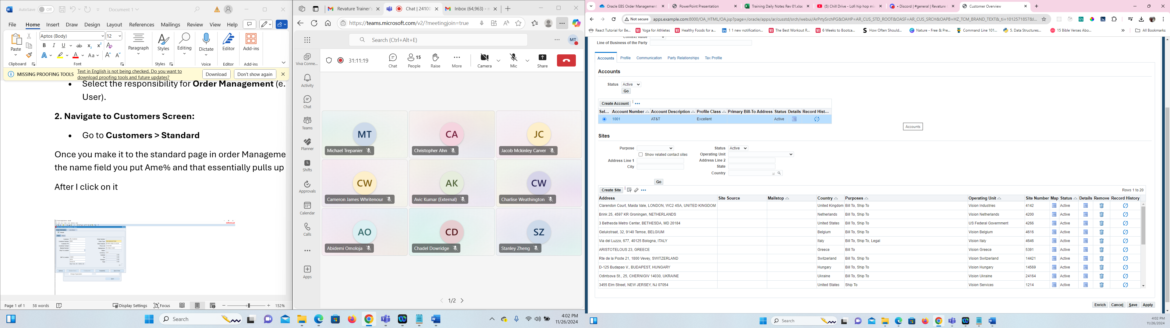

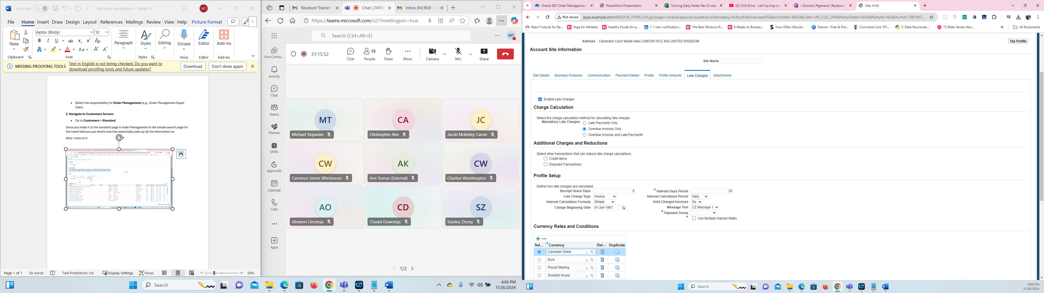

Once I selected on create account, it took me to a screen to fill out all the information. Once I filled out all the necessary information to create an account, I saved it, it took me to the screen below where I have the account saved. When you click on details you can select where you want the shipment shipped too/billed too and when you fill out all of that information you can save it and apply it.

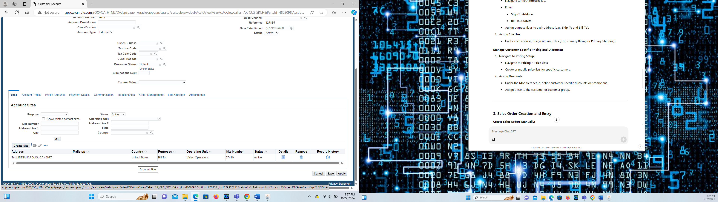

**Navigate to Sales Orders:**

* From the responsibility, go to **Orders > Sales Orders**.
* Once i’m in the navigation search bar I look up vision operations and I enter in the necessary information

**Enter Order Details:**

* In the Sales Order form:
  + Enter **Order Type**, **Customer Name**, and **Bill-To/Ship-To** addresses.
  + Add line items for products/services with quantities and pricing.
* Validate the order by clicking **Book Order**.

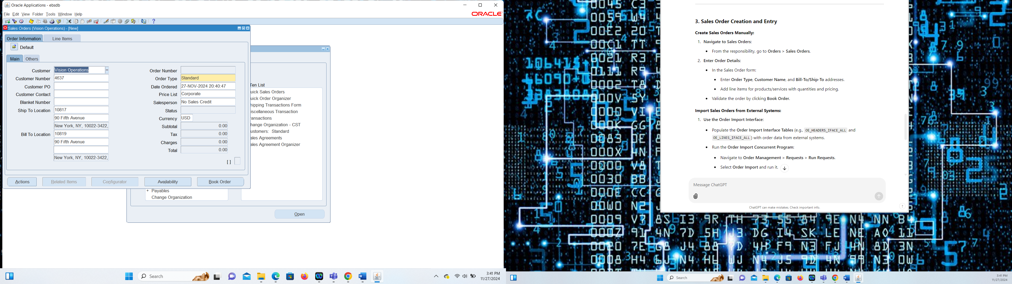

**Use the Order Import Interface:**

* Populate the **Order Import Interface Tables** (e.g., OE_HEADERS_IFACE_ALL and OE_LINES_IFACE_ALL) with order data from external systems.
* Run the **Order Import Concurrent Program**:
  + Navigate to **Order Management > Requests > Run Requests**.
  + Select **Order Import** and run it after you select the necessary data

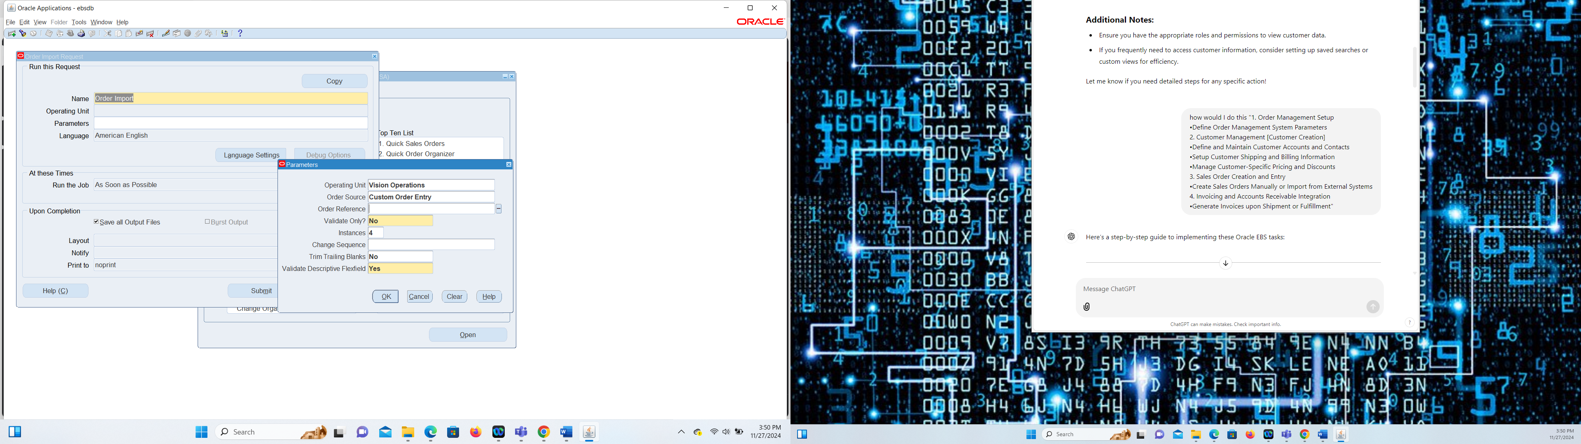

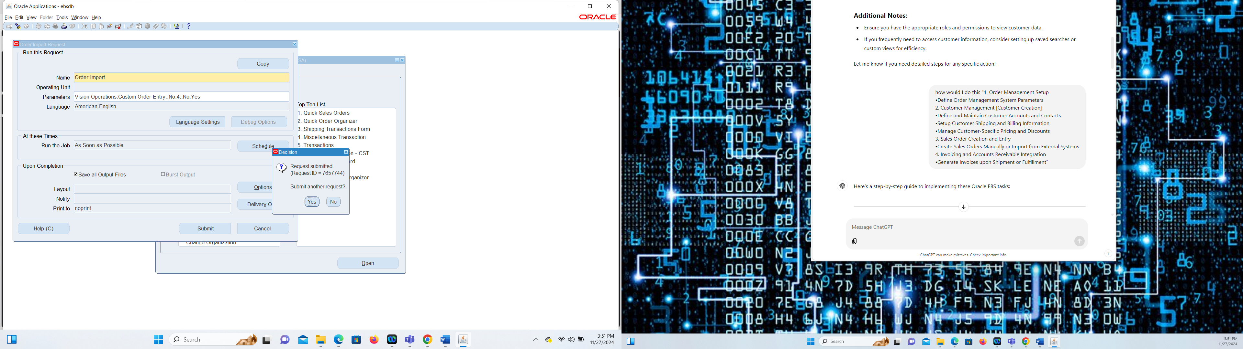

**Generate Invoices upon Shipment or Fulfillment:**

1. **Set Up Autoinvoice Integration:**
   * Navigate to **Receivables > Setup > Transactions > Sources**.
   * Define the source as **Order Entry** to integrate with Order Management.
2. **Define Transaction Types:**
   * Go to **Receivables > Setup > Transactions > Transaction Types**.
   * Define transaction types for sales invoices.
3. **Ship Confirm Sales Orders:**
   * In the Sales Order module:
     + Navigate to **Shipping > Transactions**.
     + Perform **Ship Confirm** for the order.

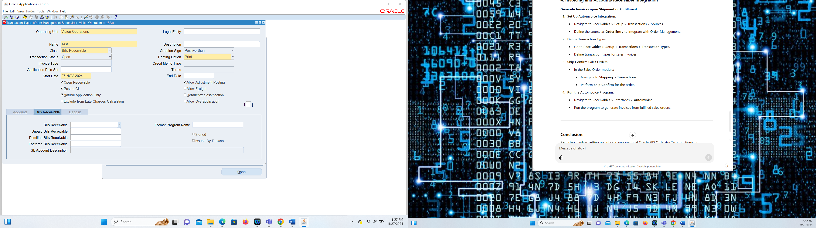

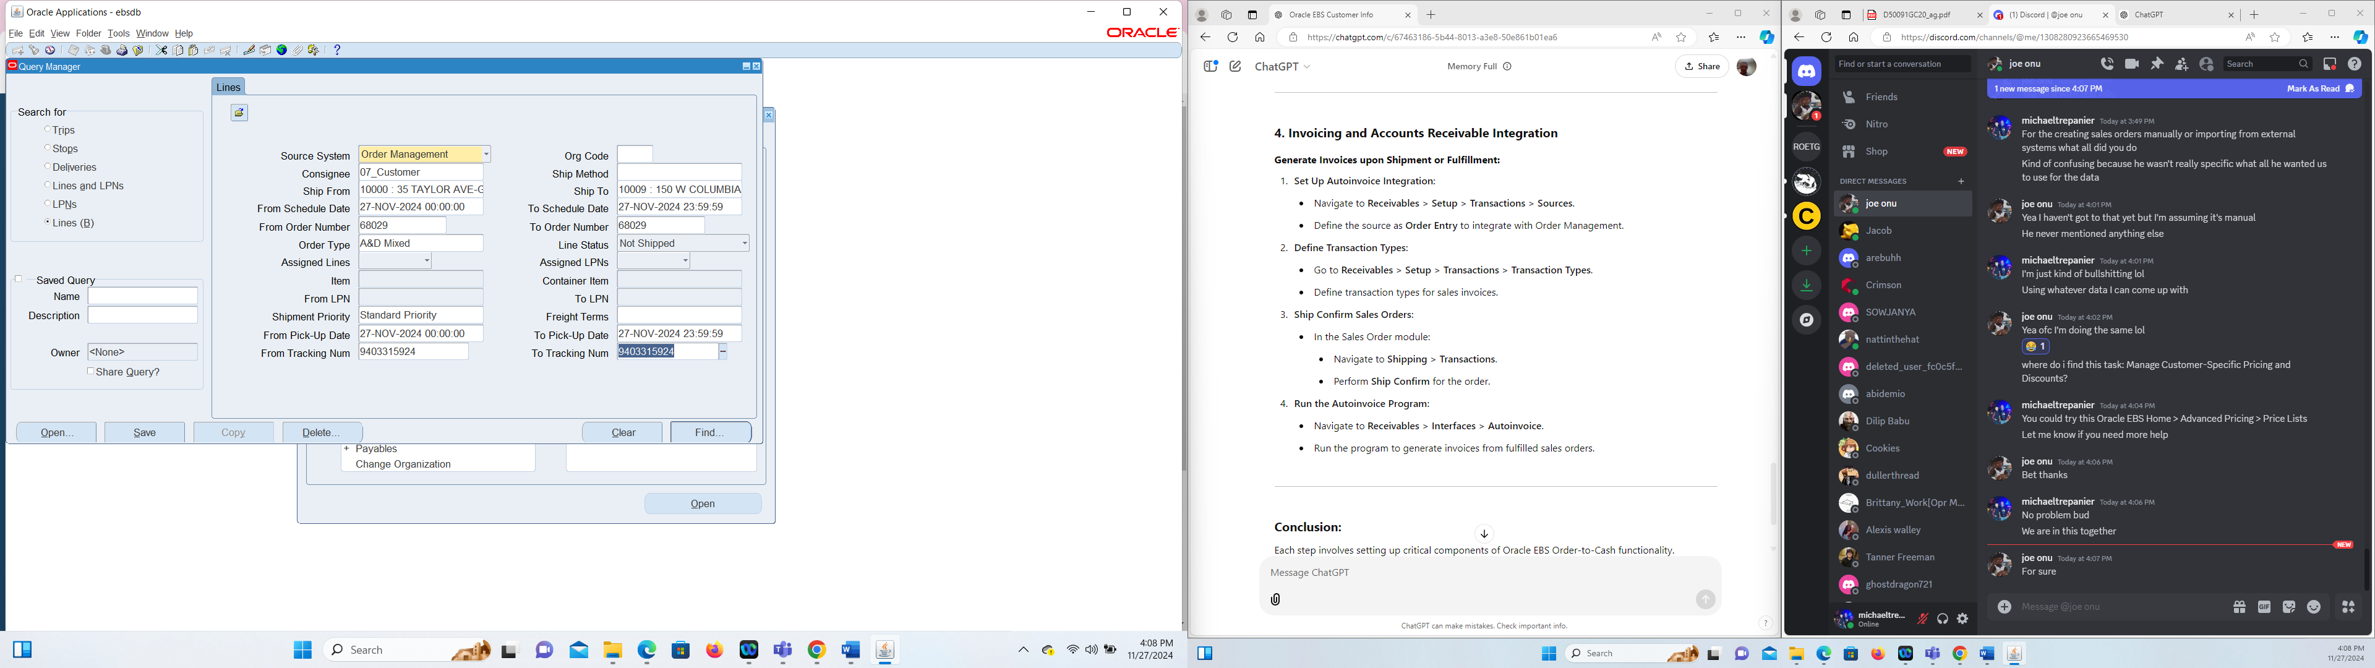

4) Navigate to **Receivables > Interfaces > Autoinvoice**.

Run the program to generate invoices from fulfilled sales orders.

From here you just enter in the data and sbumit.

